**VAISHALI BOKADIYA**

**AZURE DEVOPS DAY 2 ASSESSMENT**

**ON GIT REPO**

**Cloning a repo**

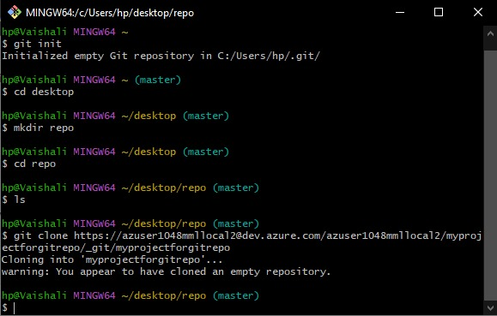

**Pushing a file**

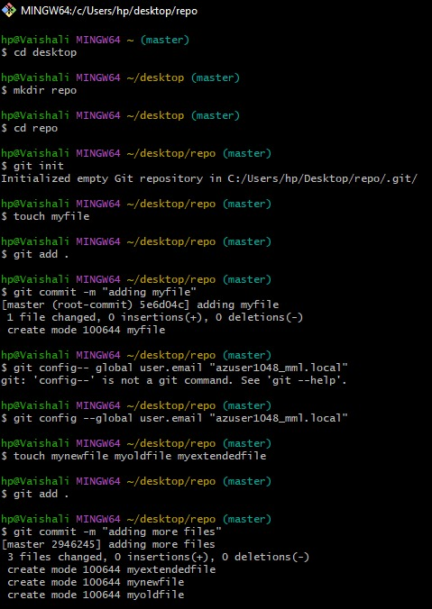

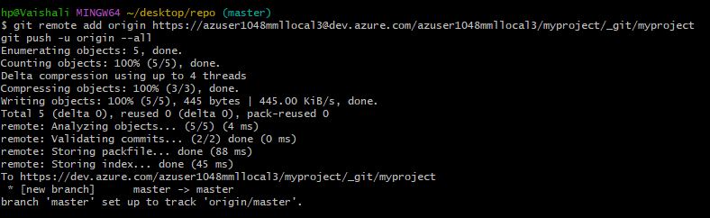

**Pulling**

